**Process on running RFID Attendance System**

The first thing you need to do when running your system is to open the XAMPP Control Panel.

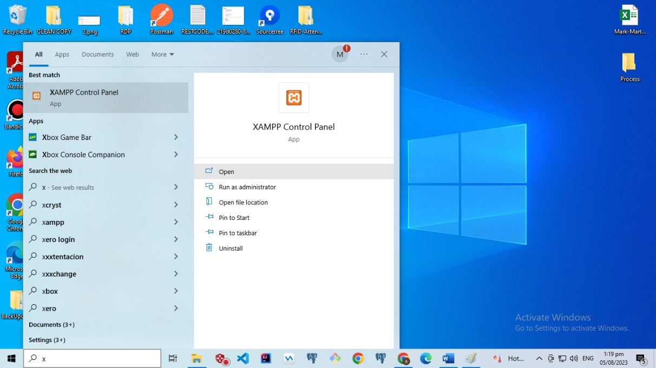

After opening the XAMPP Control Panel, you need to start Apache and MySQL.

Once Apache and MySQL are started, you should open your web browser and type the designated localhost address you have created to access your system. And automatically redirected to your home page.

Once you have been redirected to the home page, please click on "Get Started" and enter the provided account information to access the system. Use the following credentials: Email: [Admin@gmail.com](mailto:Admin@gmail.com), Password: 123

Then click on the "Login" button.

The first thing you need to do after you've been given access to the system is to go to the department tab and click the New Department button in order to add new sections and new departments.

After you have created new departments and sections, the table in the department tab will be filled with the relevant information. Next, try to highlight and copy the DE UID/token from the table for the next process in the system.

After completing the previous process, open the application called Arduino IDE. Then, paste the DE UID or token into the space that has been selected within the red rectangle in the second picture below:

Once the UID/token has been pasted, click the upload button, and the UID/token information will be loaded into the NODE of the Arduino.

Note: RFID Scanner needs to be connected to the port of the device (PC or Laptop) you are using to load the token into the scanner.

